Data-driven organization

- Collecting data
- Refine data, remove noise
- Integrate data with other sources
- Build models to describe, predict and optimize business processes and outcomes

The data driven infrastructure
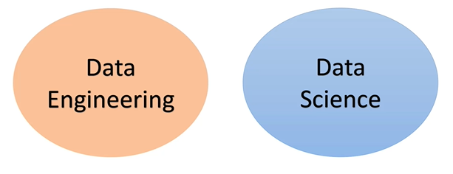
Data engineer: produces and maintains the data infrastructure
Data scientist: Analyst that uses data as raw material to produce intelligence

Data driven organizations
https://hbr.org/2012/10/making-advanced-analytics-work-for-you

DB ranking
https://db-engines.com/en/ranking

Git
https://github.com/okmich/rdbms_2_nosql

Relational Databases

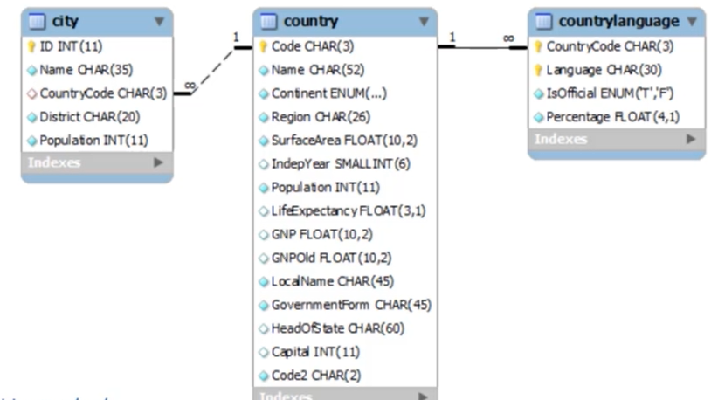
- DB built on a relational model

- Relations / Tables
  - Basic unit of data storage
  - 2D structure
- Record / Row / Tuple
  - Instances of the data
- Primary Key(s)
  - Unique identification of the table
- Fields / Columns / Properties
  - Attributes
- Data Types
  - Specified in the creation of the table for each field
- NULL
  - Can be added in any field
- Constraints
  - Ex: Column can’t receive NULL, must be unique values
- Uniqueness
  - Value unique in a particular field
- Relationships
  - Connects two tables
  - Foreign keys
- Transactions (ACID)
  - Performs actions on a database
- Index
  - Help improve the performance of read operations
  - Database objects
  - DB views
- ERD
  - Entity relationship diagram
  - Layout the entities and relationships between tables
- RDBMS
  - Relational database management system
  - Tools, programs to manage, monitor, secure the DB. Ex: MySQL, Postgres
Structured Query Language (SQL)
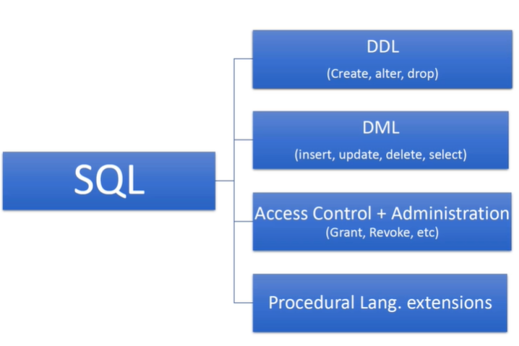
- Based on relational algebra
Data definition language
Data manipulation language

Data modeling
1
- Table for Actors
  - Ex: Store, customer, Seller
2
- Table for Actions of actors
  - Ex: Customers make orders, complains, returns
3
- Table for properties of actors that don’t fit to 2D diagram
  - Ex: Possible payment methods for customer
4
- Table for properties of actions that don’t fit to 2D diagram
  - Ex: Possible reasons for return
5
- Optimization
  - Normalization: separate tables for redundancy reduction (Ex: doc, doctor, med doc)
    - Cons: You know less from only one table. Have to read more than one table
  - Denormalization: application of JOINS to integrate tables

MySQL

- Opensource RDBMS
- Second most used DBMS (behind Oracle)
- Written in C and C++

Database systems

- Two groups
  - OLTP (Online Transaction Processing)
      - Many inserts
      - Crud applications
      - Always favor normalization
      - Must include START TRANSACTION; COMMIT; ROLLBACK;
  - OLAP (Online Analytical processing)
      - It’s more read than written
      - Provide a source for Business Intelligence
      - Data mining

Data Processing in RDBMS

- In the application space
  - LAMP stack or Django
  - Application data structure
  - Suited for OLTP application (small amount of data)

- In the database space
  - MS Access Forms or Oracle Apex
  - Database objects
  - Large amount of data
  - MapReduce, Spark, Pig: Executes the logic in the location the data exists

Indexes
→ Reduce the time to make a query
→ Queries no longer have to make a table scan

ETL (Extract, Transform, Load)

→ Integrate the business data with data from other sources
→ Saved in a Data Warehouse

Analytical Processing
→ Aggregation Queries
- Aggregation functions
- Sum, count ...
→ Analytical Queries

Logs
→ Transaction logs
→ Online logs
→ Write ahead logging: Log before writing

→ Replication
- In case something wrong happens to the data set, system can continue in another database

Relation Database Wrap-up

Scaling the RDBMS Architecture
→ Vertical scaling
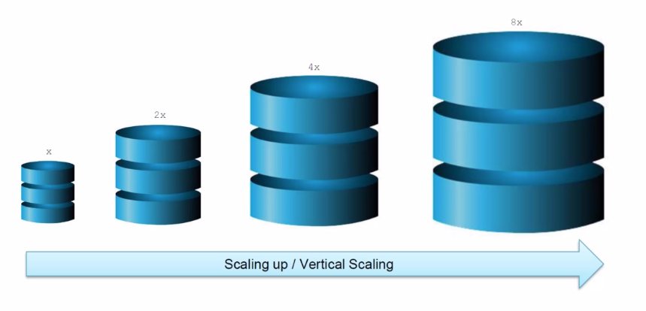

→ Horizontal Scaling
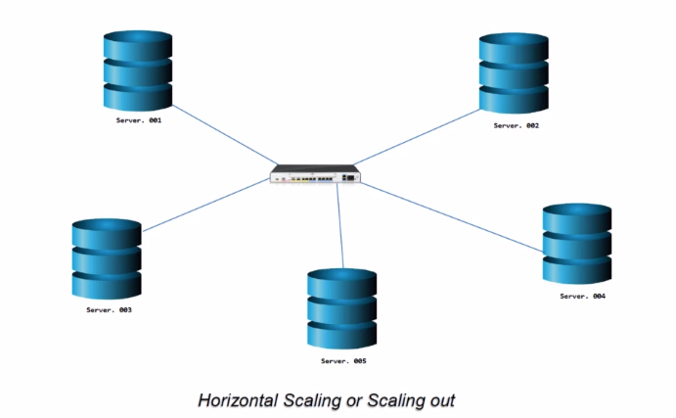
→ Machines added to network
→ Distributed databases
→ Tables broken into partitions. Each partition in a machine
→ Must have REPLICATION of all nodes. Replication FACTOR
→ RF 3. Any time data is written it’s copied 3 times in other machines.
→ Copy = Replica

Concerns of Distributed Databases
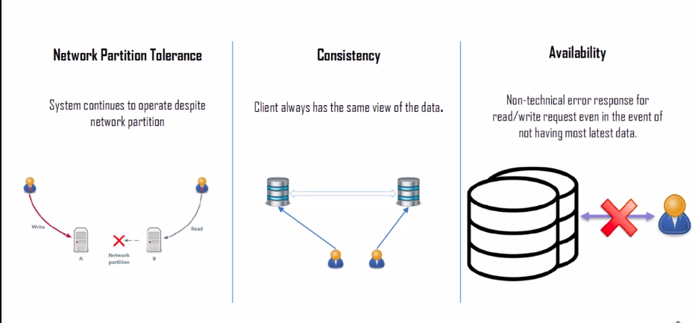
→ Network Partition Tolerance: DB continues to function
→ Consistency: All values are the same for any machine or request
→ Availability: System available for read/write requests

CAP Theory

C: Consistency, A: Availability, P: Partitioning
→ Cannot have always the 3 of them!
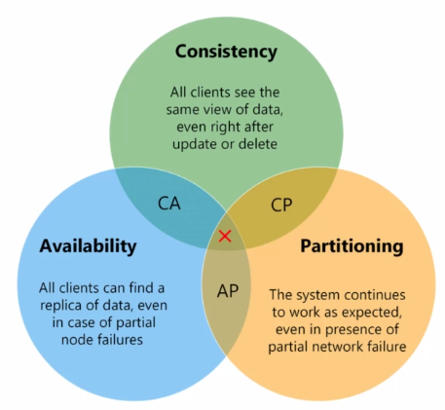

CP
→ The write is incomplete until it’s replicated to all the other machines
→ But what if at the write there was a partition failure? Write will never be complete
→ Availability not be reached!
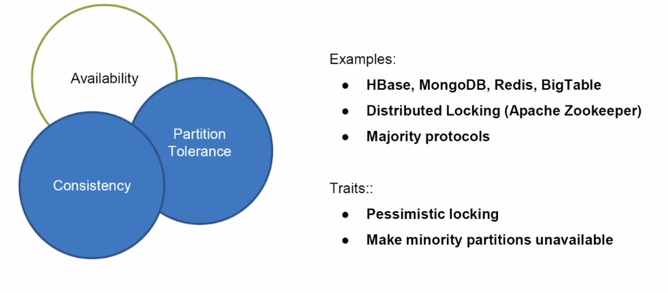

AP
→ The failed server will not be updated
→ Failed server will show outdated results
→ Consistency not reached!
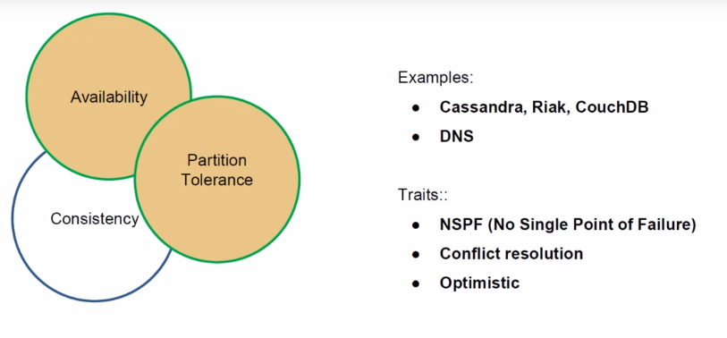

CA
→ In a single RDB it’s already possible
→ Partitioning is not reached!
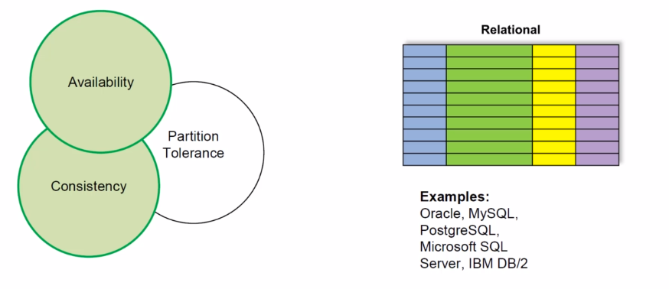

ACID vs. BASE

Other classifications of DB’s

Data Model
→ Key-value model
→ Graph model
Data Variability
→ ...
Operational Capacity
→ …

